Design Overview for <<insert name of program here>>

Name: Đỗ Vũ Khánh Quỳnh
Student ID: 105029408

Summary of Program

1) Describe what you want the program to do… one or two paragraphs.
Summary of Program
This program is a graphical music player built using the pygame library. It allows users to browse a collection of albums, view album details, and play songs interactively.
The program has two main screens:
- Library screen: Displays all albums in a grid layout.
- Detail screen: Shows selected album information and track list.
Users can:
- Click albums to view details
- Select songs to play
- Pause/resume music
- Skip tracks (next/previous)
- Adjust volume
- Toggle repeat mode
- Seek within a song using a progress bar
The program also manages playback state (current song, time, volume, etc.) using a central state object.

2) Include a sketch of sample output to illustrate your idea.
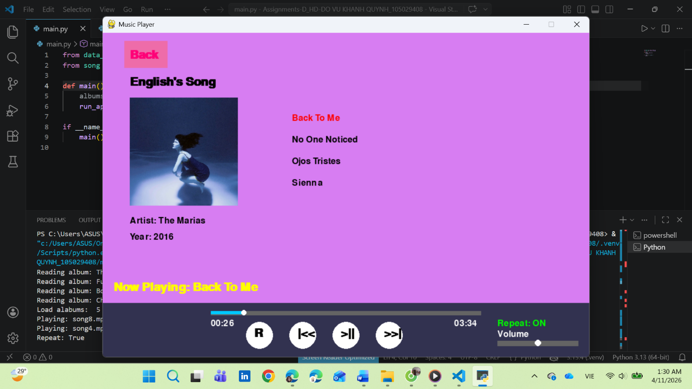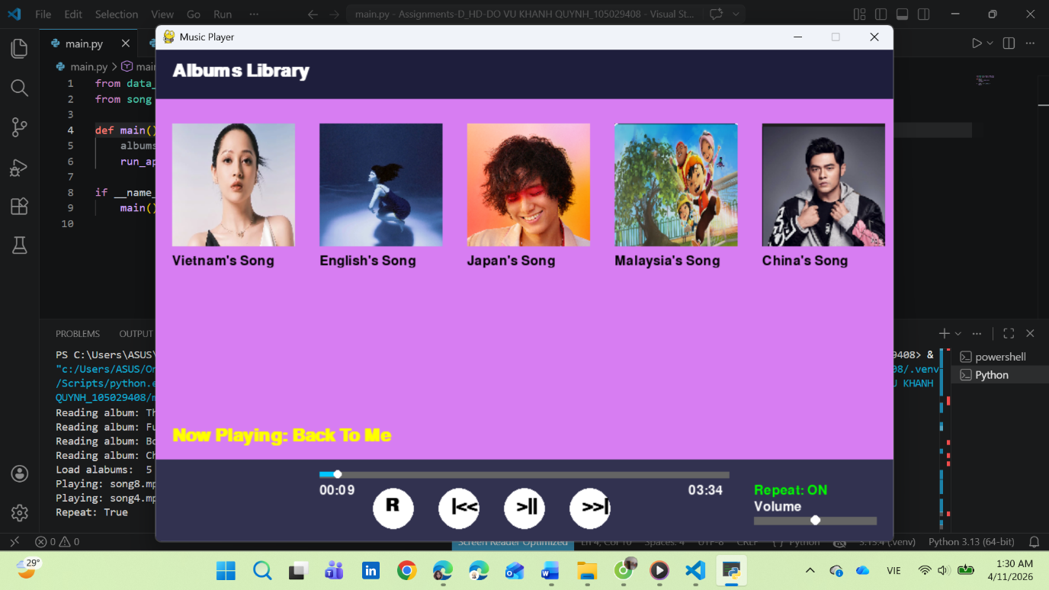

Required Data Types

Describe each of the classes and dictionaries (or enumerations) you will create using the following table (one per record).

Table 1: <<AppState details>> details
Field Name | Type | Notes
current_screen | string | "library" or "detail"
selected_album | Album | Album currently selected
selected_tracks | list | Tracks of selected album
current_song | string | Name of playing song
current_index | int | Index of current track
is_playing | boolean | Play/Pause state
repeat | boolean | Repeat mode
song_start_time | float | Start time of song
pause_time | float | Time when paused
song_length | float | Duration of song
volume | float | Range 0.0 → 1.0
dragging_volume | boolean | Volume dragging
last_click_time | float | Prevent double click

Table 2: << Album details>> details
Field Name | Type | Notes
artist_name | string | Artist name
album_name | string | Album title
release_date | string | Year
genre | string | From GENRE dictionary
tracks | list | List of Track objects

Table 3: << Track details>> details
Field Name | Type | Notes
name | string | Track name
location | string | File path of audio

Table 4: << GENRE dictionary>> details
Value | Notes
1 → Pop | Music genre
2 → Classic
3 → Jazz
4 → Rock

…

Overview of Program Structure

List the main functions/procedures you are going to need to create this program. For each function/procedure provide its name and a brief description of what it will do.

Folder: screens

1. albums_library.py
- Draws main library screen
- Displays albums in grid
- Draws:
  - Header
  - Albums
  - Controls
  - Progress bar
- Shows "Now Playing"

2. albums_detail.py
- Displays selected album
- Shows:
  - Album image
  - Artist + year
  - Track list
- Highlights:
  - Hover track
  - Current playing song
- Reuses controls + progress bar

Folder: controls

3. app_state.py
- Stores entire app state
- Acts as central data manager
- Keeps track of:
  - UI navigation
  - Playback
  - Timing
  - Volume

4. player_logic.py
Handles music playback:
- play_track()
→ load & play song
- toggle_pause()
→ pause / resume
- update_player()
→ repeat logic

5. ui_controls.py
Handles user input:
- handle_album_click()
- handle_track_click()
- handle_back_button()
- handle_playback_controls()
- handle_seek()
- handle_repeat()
- handle_mouse_click() (main controller)

Other files

main.py
- Program loop
- Event handling
- Switch between screens
- Calls update + draw

data_files.py
- Reads album data from file
- Creates Album + Track objects

input_functions.py
- Utility input functions (not heavily used in GUI)
Main Program Flow
- Initialize pygame
- Load albums from file
- Start main loop:
  - Handle events (mouse, keyboard)
  - Update state
  - Update player (repeat logic)
  - Draw screen based on state

Don’t spend too long on this at this stage. Focus on the main things you think you are likely to need and you can build on this as your program develops.

Include a structure chart (once you have your proposal approved by your tutor)

